**Phase 4: Development Part 2**

Introduction:

We proceed with the development of our image recognition project in Phase 4, "Development Part 2," by configuring IBM Cloud and combining Watson Studio with Watson Visual Recognition. The development of a successful image recognition system requires following these fundamental procedures.

**Step 5: Sentiment Analysis Integration:**

* **Description: In this phase, we are incorporating sentiment analysis to generate captions that not only describe the content but also capture the emotions and mood of the images.**
* **Outcome: Users will have access to emotionally rich and contextually relevant captions for their images.**

**Code Snippet (Python):**

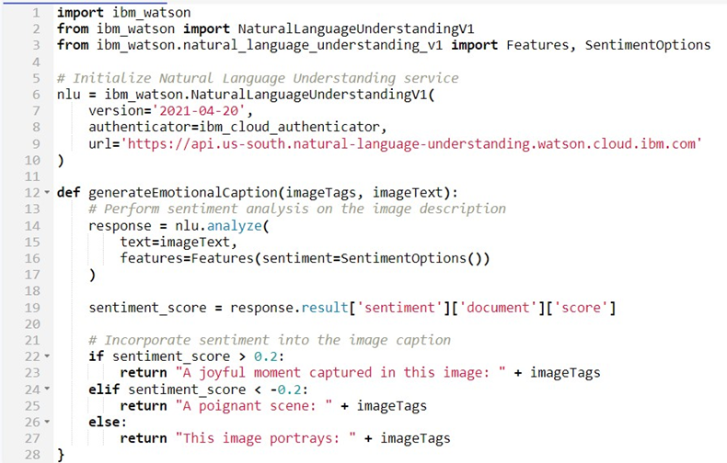

**Step 6: Enhancing User Engagement:**



**Code Snippet (JavaScript):**

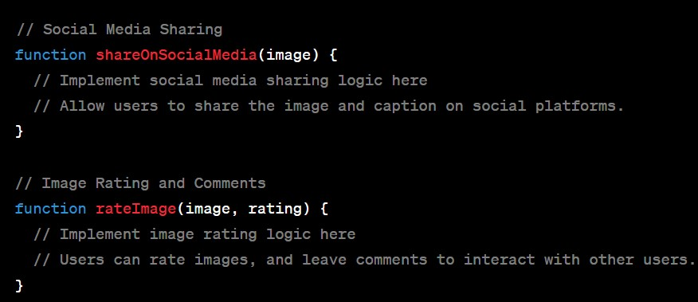

**Step 7: IBM Cloud Setup and Watson Studio Integration:**

**Watson Studio and Cloud Object Storage Setup**



Step 8:Create a Project and Add Watson Visual Recognition Service:

**Create a Project**



Add Watson Visual Recognition Service:



Analyze Images with Watson VR **:**



CONCLUSION:

We've made great strides in Phase 4, "Development Part 2," by integrating sentiment analysis, improving user engagement features, and configuring IBM Cloud with Watson Studio integration. These tasks lay the groundwork for our image recognition project by giving users a rich, emotional experience and the instruments they need to analyze images effectively.